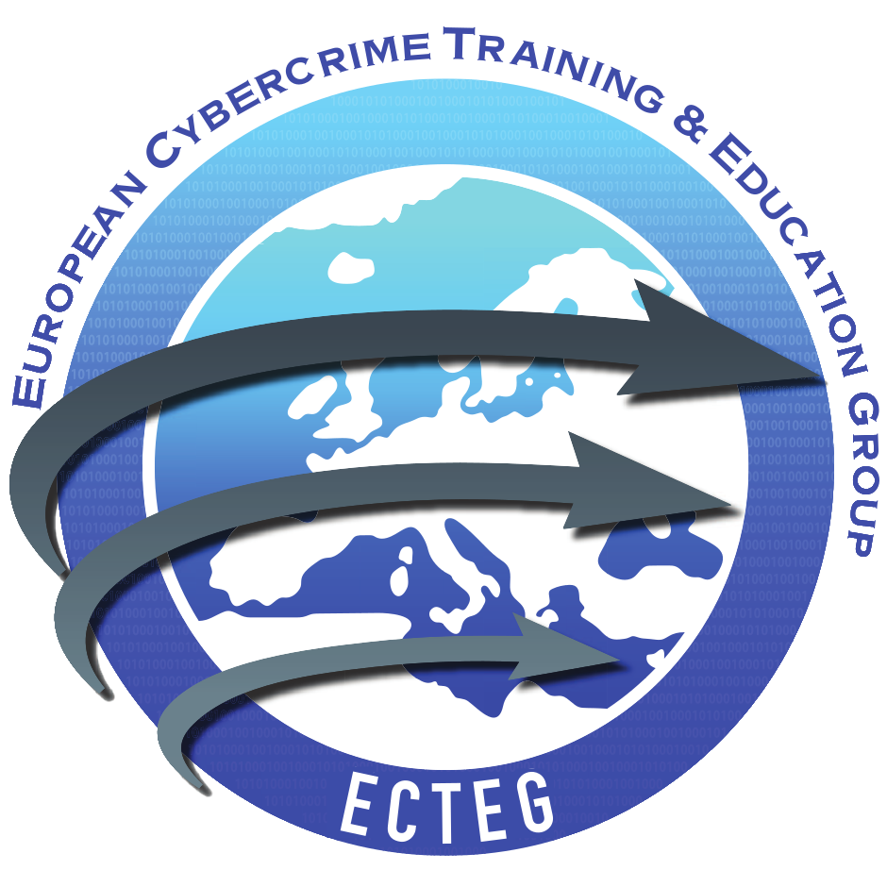

Use of ECTEG Course Material
This document covers use of ECTEG Training Materials developed to support the harmonization of cybercrime training programme that is now managed by the European Cybercrime Training and Education Group, ECTEG, International Non-Profit Association registered in Belgium as “Association Internationale Sans But Lucratif” below number BE.0672.385.489.
Once approved and signed by both parties, this document take effect as an Agreement for use of specified ECTEG material for specified organised training activities.
Recipient:
Official Name:
Official Address:
Country:
Status:
Applying to organise a course on following ECTEG package

ECTEG reference number:
(provided by ECTEG when application granted)

Article 1 Terms used in this Agreement
“Law Enforcement Agency”
refers to a Law Enforcement Agency, or “LEA”, which must be a recognised law enforcement agency authorised by national law in a member state of the European Union or recognised by Interpol as a law enforcement agency of a member country of Interpol.
“Academic member”
refers to an academic organisation that is an ECTEG member and is working with law enforcement to deliver this material on a non-commercial LE only basis.
“Academic partner”
refers to an academic organisation that is NOT an ECTEG member and is working with law enforcement to deliver this material on a non-commercial LE only basis with a supporting letter from the beneficiary LEA.
“International organisation partner”
refers to an international organisation that is an ECTEG member and is delivering ECTEG material on a non-commercial Law Enforcement, or “LE” only basis.
“International organisation partner”
refers to an international organisation that is NOT an ECTEG member working with law enforcement to deliver ECTEG material on a non-commercial LE only basis with a supporting letter from the beneficiary LEA.
“Intellectual Property Rights”, “IP Rights”
are copyright, patents, trademarks, trade names, get-up and logos, service marks, business names (including internet domain names), design rights, database rights, rights in undisclosed or confidential information (such as know-how, trade secrets and inventions) and all other intellectual property or similar property rights of whatever nature (whether registered or not and including applications to register or rights to apply to registration) which may now or in the future subsist anywhere in the world.
“Background IP’’
are background intellectual property rights which include intellectual property already owned by one or multiple members of ECTEG on the date of transfer of the Training Material.
“Not for Profit” and “Non-Profit”
is where no commercial profit is gained by the provider of the Training Materials except those costs necessitated by the delivery of the Training Materials. Typical expenses include room rental, equipment rental, productions of course materials, the production/supply of student resources, fees payable to trainers for the delivery of the course, expenses necessarily incurred by trainers in attending courses, approved fees and expenses incurred by students in attending courses.
“Recipient” and “Applicant”
refers to the individual, or agency representing the Law Enforcement Agency or ECTEG Academic Partner, that is the recipient of Training Materials from ECTEG, and who applies for ECTEG Training Materials by filling in this document.
“Training delivery body”
refers to the individual, or agency in charge, that will organise and deliver training based on ECTEG material.
“Trainer”
refers to the individual in charge that will deliver, fully or partly, alone or as part of a team, the training based on ECTEG material.
“Training activities”
refers to the activity of training, organised by the recipient, in a specified location, within a specified period.
“ECTEG logo”, “Material developer logo”
refers to all figurative marks, logos or text of ECTEG, or any other organisation that contributed to material development on original ECTEG training materials.
“EU Commission logo”, “European Commission Logo”
refers to all figurative marks, logos, or the text “funded by the European Commission” included on original ECTEG materials.
“Training Material”, “Training Materials”, “ECTEG materials”
covers trainer manuals, student manuals, trainer presentations, files and tools used for exercises, criminal evidence mocks, virtual machines and all associated files or documents included and delivered within an ECTEG course package specifically identified by title during the application process.
“Parties”
includes, but is not limited to, LEAs, Academic Members, Academic Partners, International Organisation Partners, Recipients, Applicants, Training Delivery Bodies, Students and Trainers.

Article 2 Use of the ECTEG materials for training activities
2.1 This Agreement is valid for the organisation of a single ECTEG course module, which will include one or multiple training activities, within the agreed specified period.
2.2 The Recipient can deliver the training themselves, or they can delegate delivery of the training, fully or partially, to specified ECTEG approved bodies named by the Recipient and approved by ECTEG during the ECTEG Training Materials application process. The Recipient will also responsible for ensuring that any recommendations from the course training manual regarding classroom installation and configuration, network configuration, computers settings are applied. They will also guarantee that the advised number of trainers is provided and that trainers are competent to cover topics in the ECTEG module being taught.
2.3 Provided Training Materials shall be used exclusively for the purposes of training law enforcement personnel in forensic computing and cybercrime investigation as described hereinafter in this Agreement.
2.4 Training of law enforcement personnel facilitated by the release of the ECTEG Training Materials shall be delivered on a “non-profit basis” where no commercial profit is gained by the provider of the ECTEG Training Materials, except for covering expenses necessitated by the delivery of the ECTEG Training Materials. Typical expenses include room rental, equipment rental, productions of course materials, the production/supply of student resources, fees payable to trainers for the delivery of the course, expenses necessarily incurred by trainers in attending courses, approved fees and expenses incurred by students in attending courses.
2.5 Access to ECTEG Training Materials, including for trainers, translators, interpreters and course designers is restricted to members of law enforcement.
2.6 In the case of persons who are not members of Law Enforcement accessing ECTEG Training Materials, they must first be approved by the law enforcement agency in charge of the training activity. The law enforcement agency must communicate this approval to ECTEG directly with details of the non-law enforcement personnel. When this approval is received by ECTEG, the ECTEG agreement will be provided within a two-week period.
2.7 The Recipient will provide the ECTEG board, at least four weeks before the first training activity commences, the dates and places of when and where training activities will take place. The recipient must also advise the ECTEG board as soon as possible if modifications or changes are made.
2.8 The Recipient will allow an ECTEG appointed and funded expert to attend training activities as an observer. When needed, and with agreement from the expert and the training delivery body, the expert may take part in training activities as a trainer.
2.9 In the case where any person (hereinafter named the ‘contact person’) is not able to guarantee any aspect of this Agreement, the Recipient will inform the ECTEG board immediately and name a new contact person in their place as soon as possible and before the start of any scheduled training activity.
2.10 All ECTEG course developer and EU commission logos, branding and copyright statements on all ECTEG Training Materials provided, including when translated, will be maintained and modified, but under no circumstances can be removed.
2.11 When the Recipient or Training Delivery Body needs to modify or translate ECTEG Training Material, they guarantee to follow ECTEG course development standards. ECTEG course development standards can be obtained by sending a request to contact@ecteg.eu
Any breach of this condition will result in immediate revocation of the licence to use ECTEG Training Materials, and will render that recipient liable to immediately returning all ECTEG Training Materials provided back to ECTEG.

Article 3 Intellectual Property Rights
Regarding Intellectual Property Rights, the Parties agrees as follows:
3.1 ECTEG Training Material IP Rights and background IP Rights are owned by the ECTEG members who are responsible for the development of the material. All ECTEG members agree to distribute their Training Material developed within ECTEG in accordance with ECTEG distribution rules.
3.2 IP Rights of Open source software tools and documents included in ECTEG course packages remain fully owned by the original owners.
3.3 If ECTEG material is modified, ECTEG and the original background IP owners will keep all background rights, except for those parts of the modified training developed exclusively without the use of ECTEG material.
3.4 If ECTEG material is translated and then modified for local laws in that country or territory, the entities involved in translating the material will acquire IP rights on the new translated and modified version of the material, however ECTEG and the original background IP owners will keep all background rights on the original version.

Article 4 Non-Disclosure Agreement
4.1 Parties agree that Training Material content shall be treated as proprietary and confidential and may be used and/or disclosed only in accordance with the provisions of this Agreement. ECTEG IP Rights and all Background IP rights Holders and the Recipient Parties shall take strict confidentiality into consideration regarding all content and information relating to ECTEG Training Material.
4.2 Prior to getting access to ECTEG Training Material, all individual recipients are required to sign the NDA signature page in this document, including the recipient contact person responsible for the training, trainers, and additional training partners or approved personnel.
4.3 All NDAs and Training Material sent to each applicant will be recorded by ECTEG for administrative purposes, and all details will be provided to the background IP rights holder(s).
4.2 Recipients shall treat the ECTEG Training Material they receive as confidential and are not entitled to further distribute, sell, license, sublicense, rent, lease and/or otherwise use for commercial or non-profit purposes the Training Material or any part thereof.
4.3 In exception to the previous article, ECTEG Training Materials may be provided to an approved training delivery body, if any, and all trainers will be entitled to use it exclusively for the training activities hereinafter described.
4.4 All trainer resource packs delivered as part of ECTEG Training Material to Recipients must not be given or passed to any other person including students on the course(s). If a trainer, who has been granted access to the training, receives a request for their trainer pack from a student or person who themselves is entitled to the material directly by ECTEG, the trainer has no authority to pass the trainer resource pack to this person.
4.5 Any recipient of ECTEG Training Materials who receives a request for the release of the ECTEG Training Materials should refer this request for the attention of the ECTEG.
4.6 ECTEG may include hidden authentication or other information in the materials to enforce non-disclosure conditions.
4.7 In the event of a security breach or unauthorised access to ECTEG Training Material, the Recipient must immediately inform the Board of ECTEG and, if any, the LEA that provided the supporting letter. All hard copy printed material and electronic documentation needed for security breach investigation must be immediately provided to the ECTEG board or LEA investigating unit upon request.
Any breach of this condition will result in the immediate revocation of the licence provided to use the ECTEG Training Materials and render the Recipient liable to immediately return all provided training materials. The ECTEG board may initiate any legal case and take any counter measures to protect IP rights, background IP rights and ECTEG member’s interests.

Article 5 Course Evaluation Report
5.1 The Recipient agrees to carry out an evaluation of the training course delivered and to supply this course evaluation report to the Board of ECTEG two months after each activity at the latest. This information will be used by ECTEG in the course upgrade process and in the gathering of statistical information.
5.2 The Course Evaluation report will include:
- Reference number (this number will be provided with the materials)
- Course title
- Dates of delivery and the location where the course was delivered
- The number of trainees who took part at the training activity
- The names and contact details of the trainers (including telephone and email addresses) who agree to be identified and included into ECTEG trainer’s database.
- A comprehensive overview of trainer’s and student’s comments on ECTEG course material, and any detailed observations on deficiencies therein.
5.3 If the training activities in the Course Evaluation Report differ from what was originally planned, including change of location, the report must include a brief explanation as to why these changes took place.
5.4 To facilitate reporting, which must be submitted within two months of the completion of the last training activity, several training activities may be consolidated in one report. Any issues identified relating to specific training activities need to be clearly documented in the course evaluation report.

Article 6 Application process
6.1 First, the Recipient must send this Agreement form completed and signed, and sent by e-mail to
contact@ecteg.eu.
6.1 The application will be approved (or refused) within two weeks of receipt of this Agreement form, on a case per case basis by the Board of ECTEG.
6.2 Applications for access to ECTEG material by ECTEG Associate Members must be accompanied by a letter of approval from their local LE ECTEG member.
6.3 The board of ECTEG will reserve the right to refuse the distribution of ECTEG Training Material for any stated reason.
6.4 ECTEG reserves the right to rescind access to ECTEG Training Material at any time.
6.5 Once approved by both parties, this application form takes effect as an official Agreement.
6.6 Once approved, ECTEG will deliver access to the specified ECTEG Training Material within 2 weeks.

Article 7 Entry into force, duration and termination
7.1 This Agreement shall enter into force on the date of its signature by the parties hereto.
7.2 Parties may elect to terminate this Agreement at any time by mutual consent. Upon termination of the Agreement by mutual consent, the Recipient commits to return to ECTEG all provided Training Material, including if applicable, all Upgrades.
7.3 Either ECTEG and the Recipient are entitled to unilaterally terminate the Agreement by providing no less than three months written notice prior to the desired termination date. In the event of termination by unilateral action, the Recipient commits to return to ECTEG all ECTEG Training Material provided and if applicable, all Upgrades.

Article 8 Liability of the Parties and warranties
8.1 The recipient party acknowledges that ECTEG shall not be liable for any direct, indirect, consequential, special or other damages suffered by the Recipient Party or any others resulting from the transfer and/or use of ECTEG materials.
8.2 ECTEG shall not be liable for damage sustained by the Recipient Party in the performance of the Agreement. To the best knowledge and belief of ECTEG, provided Training Material, is original, legal, decent and truthful, complies with laws and regulations, does not infringe the Intellectual Property rights of any third party, is not defamatory, unreliable or misleading. However, ECTEG offers no guarantee for the accuracy, completeness or timeliness of the information contained therein.
8.3 No Party shall be held liable for failure to perform its obligations under this Agreement if it can prove that the partial or full non-performance was due to an impediment beyond its control and that it could not reasonably be expected to have taken the impediment into account at the time of the conclusion of the Agreement or at any time subsequently or to have avoided or overcome it or its consequences. Each Party will notify any such force majeure as soon as possible. It shall further use its best efforts to resume performance as quickly as possible and shall suspend performance only for such period as is necessary because of the force majeure event.
8.4 The Recipient is solely responsible for the implementation, enforcement and control of conditions in this Agreement. In case where the Recipient uses another training body, trainers, course managers, translators, interpreters, course managers or any other person involved in Training Material delivery, update, or modification, the Recipient will inform them of the conditions and take any measure to control their application.
8.5 The Non-Disclosure Agreement, or “NDA,” will place both organisational and personal restriction on the use of the ECTEG Training Material. The NDA may require local law enforcement to carry out checks on the members of academia who have access to the ECTEG Training Material.

Article 9 Governing law and dispute resolution
9.1 All Parties shall make every effort to settle amicably any dispute, question or difference relating to this Agreement which may arise between them. Pending the resolution of any dispute pursuant to this Article, the Parties agree that performance of their responsibilities shall be pursued by each diligently.
9.2 If at any time question, a dispute or differences arise between the Parties in relation to or about this Agreement, including request from any ECTEG member who contributed to provided material development and who is a background IP rights owner, the Parties will endeavour to resolve it by a process of consultation, consensus and application of common sense.
The purpose of the consultation shall be to review and agree so far as is practicable the action taken to solve the problem that has arisen and the Parties shall negotiate with each other in good faith to that end. Each Party shall respond to a request for amicable settlement within 15 Working Days of such a request.
The period to reach an amicable settlement shall be 30 Working Days from the date of the request. An extension in this period can be agreed between the parties. If, however, resolution cannot be achieved, the Parties shall seek to prepare an agreed frame of reference for submission of the dispute to arbitration.
Each Party shall meet their own costs unless the arbiter finds that one Party (or Parties) has/have acted manifestly unreasonably and should as a result bear all or part of the cost of the other Party or Parties.
9.3 Upon agreement of a frame of reference, the parties will refer the dispute to an Arbitration Board composed of two arbitrators each selected by one of the parties, and of a presiding arbitrator, appointed by the other two arbitrators.
9.4 Alternatively, the parties may submit the dispute for decision to a single arbitrator selected by them by common agreement.
9.5 When the recipient of the materials is Council of Europe, both parties agrees that, failing such agreement, that arbitrator will be selected by the President of the Tribunal de Grande Instance of Strasbourg.
9.6 The arbitral decision shall be binding upon the parties and there shall be no appeal from it.
9.7 This Agreement is governed by and shall be construed in accordance with the laws of Belgium.

Application Details:
Purpose of the Agreement:
In case of materials will be translated, specify in what language(s):
In case of the Recipient delegating training delivery to another organisation, please specify that organisation:

Target audience profile (skills, role, LEA bodies, countries):

Training activities
Period when training activities will be organised:
(may not exceed 24 months and must start within the 12 months application submission)
How many sessions are planned to be organised in this period:
Estimation of how many trainers will be involved:
Contact person (working for Recipient):
- Name and Surname:
- Function:
- Address:
- Business e-mail: @
- Phone number: + -
- Address (street, city, country):
Comments:

Contact person who will complete and sign the first row on last page NDA table
In the application of article 2.9, where the here-mentioned contact person is not able to guarantee respect of this Agreement, the recipient will inform the ECTEG board immediately and name a new contact person as soon as possible, and before the start of any scheduled training activity. An updated version of this page must then be sent as an appendix to this Agreement.

Signature of the parties
Signature for the Recipient:
This document needs to be signed by the person who has the authority or the delegated power of attorney for the applicant organisation.
Insert below a handwritten copy of the following sentence:
“I acknowledge to guarantee the use of ECTEG material following the specified conditions in this Agreement.”
Handwritten signature:
Surname and Name:
Position in the organisation:
Place: date:

Attached LEA Letter of support: from:
If you are applying for this material as an ECTEG Academic Associate Member, please ensure you have attached a letter of support from your LE partner, in accordance with the amended rules of ECTEG.
Signature for ECTEG after approval of the application by ECTEG board:
Surname and Name:

Position in the organisation:

Place: Date:

Non-Disclosure Agreement approval form
In application of Article 4, the Recipient contact person responsible for the training delivery body (if any), trainers and individuals, are all required to sign this form before getting access to ECTEG Training Material. By signing, they acknowledge to be notified and agree with Article 3 and Article 4, not to disseminate, copy, transmit, publish, or use ECTEG Training Materials or supporting materials including soft copy electronic ECTEG Training Materials, or ECTEG materials here described, except for student materials which can be delivered to students attending the training activities as outlined in this Agreement.
 | Surname | First Name | Organisation | date | signature
1
2
3
4
5
6
7
8
9
10
11

